Measurement Accuracy
# Source: AI Source: Provided by: [Data Path: Persons Table -> ID Column: 1, Name_En Column: Motasem Essam] -> From: [ChatGPT] on [7/17/2026]
Measurement Accuracy is the degree to which a measured value agrees with the true value or an accepted reference value of the quantity being measured. It is one of the most important characteristics of any measurement because it indicates how close the measurement is to the correct value.
Accuracy is fundamental in science, engineering, manufacturing, medicine, metrology, quality control, and laboratory work.

Definition
# Source: AI Source: Provided by: [Data Path: Persons Table -> ID Column: 1, Name_En Column: Motasem Essam] -> From: [ChatGPT] on [7/17/2026]
Measurement Accuracy is the closeness of agreement between a measured value and the true value (or an accepted reference value) of the quantity being measured.
Since the true value is often unknown, accuracy is usually evaluated by comparing measurements with a calibrated reference standard.

Purpose
# Source: AI Source: Provided by: [Data Path: Persons Table -> ID Column: 1, Name_En Column: Motasem Essam] -> From: [ChatGPT] on [7/17/2026]
Measurement accuracy is used to:
- Ensure reliable measurements.
- Verify product quality.
- Support scientific research.
- Reduce measurement errors.
- Improve manufacturing processes.
- Maintain compliance with standards.
- Increase confidence in measurement results.

Characteristics
# Source: AI Source: Provided by: [Data Path: Persons Table -> ID Column: 1, Name_En Column: Motasem Essam] -> From: [ChatGPT] on [7/17/2026]
An accurate measurement is:
- Close to the true value.
- Repeatable when measured correctly.
- Obtained using a calibrated instrument.
- Less affected by systematic errors.

Example
# Source: AI Source: Provided by: [Data Path: Persons Table -> ID Column: 1, Name_En Column: Motasem Essam] -> From: [ChatGPT] on [7/17/2026]
Suppose the true length of a metal rod is:
True value: 100.00 cm
Measurements:

Measured Value | Accuracy
100.01 cm | Very high
99.99 cm | Very high
102.50 cm | Low
The first two measurements are highly accurate because they are very close to the true value.

Factors Affecting Accuracy
Measurement accuracy depends on:
- Instrument calibration.
- Instrument quality.
- Instrument resolution.
- Environmental conditions.
- Proper measurement technique.
- Operator skill.
- Systematic errors.

Improving Accuracy
# Source: AI Source: Provided by: [Data Path: Persons Table -> ID Column: 1, Name_En Column: Motasem Essam] -> From: [ChatGPT] on [7/17/2026]
Accuracy can be improved by:
- Using calibrated instruments.
- Selecting the appropriate measuring instrument.
- Following proper measurement procedures.
- Reducing environmental influences.
- Regular instrument maintenance.
- Eliminating systematic errors.

Sources of Inaccuracy
# Source: AI Source: Provided by: [Data Path: Persons Table -> ID Column: 1, Name_En Column: Motasem Essam] -> From: [ChatGPT] on [7/17/2026]
Common causes include:
- Calibration errors.
- Instrument wear.
- Manufacturing defects.
- Temperature changes.
- Incorrect reading.
- Parallax error.
- Improper measurement technique.

Applications
# Source: AI Source: Provided by: [Data Path: Persons Table -> ID Column: 1, Name_En Column: Motasem Essam] -> From: [ChatGPT] on [7/17/2026]
Measurement accuracy is essential in:
- Engineering
- Manufacturing
- Medicine
- Physics
- Chemistry
- Metrology
- Surveying
- Aerospace
- Electronics
- Scientific research

Everyday Examples
# Source: AI Source: Provided by: [Data Path: Persons Table -> ID Column: 1, Name_En Column: Motasem Essam] -> From: [ChatGPT] on [7/17/2026]
Examples include:
- Measuring body temperature with a calibrated thermometer.
- Weighing ingredients on a kitchen scale.
- Measuring fuel quantity.
- Determining blood pressure.
- Measuring room dimensions.
- Timing athletic events.

Accuracy vs. Precision
# Source: AI Source: Provided by: [Data Path: Persons Table -> ID Column: 1, Name_En Column: Motasem Essam] -> From: [ChatGPT] on [7/17/2026]
Accuracy and precision are related but not identical.
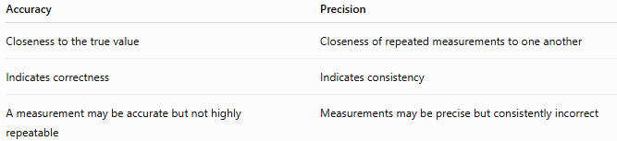
Accuracy | Precision
Closeness to the true value | Closeness of repeated measurements to one another
Indicates correctness | Indicates consistency
A measurement may be accurate but not highly repeatable | Measurements may be precise but consistently incorrect
Example:
- Measurements: 100.0, 100.1, 99.9 cm ( true value = 100 cm) → Accurate and precise.
- Measurements: 95.0, 95.1, 94.9 cm (true value = 100 cm) → Precise but not accurate.

Accuracy vs. Error
# Source: AI Source: Provided by: [Data Path: Persons Table -> ID Column: 1, Name_En Column: Motasem Essam] -> From: [ChatGPT] on [7/17/2026]
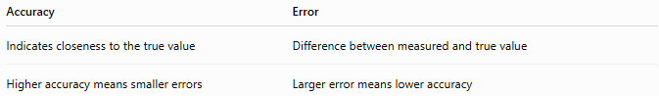
Accuracy | Error
Indicates closeness to the true value | Difference between measured and true value
Higher accuracy means smaller errors | Larger error means lower accuracy

Accuracy vs. Resolution
# Source: AI Source: Provided by: [Data Path: Persons Table -> ID Column: 1, Name_En Column: Motasem Essam] -> From: [ChatGPT] on [7/17/2026]
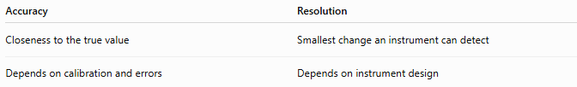
Accuracy | Resolution
Closeness to the true value | Smallest change an instrument can detect
Depends on calibration and errors | Depends on instrument design
An instrument may have high resolution but still produce inaccurate measurements if it is not calibrated correctly.

Accuracy vs. Sensitivity
# Source: AI Source: Provided by: [Data Path: Persons Table -> ID Column: 1, Name_En Column: Motasem Essam] -> From: [ChatGPT] on [7/17/2026]
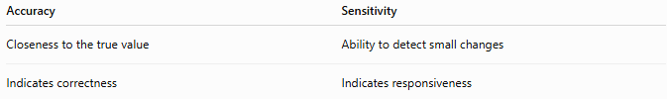
Accuracy | Sensitivity
Closeness to the true value | Ability to detect small changes
Indicates correctness | Indicates responsiveness

Types of Accuracy

Absolute Accuracy
# Source: AI Source: Provided by: [Data Path: Persons Table -> ID Column: 1, Name_En Column: Motasem Essam] -> From: [ChatGPT] on [7/17/2026]
The closeness of a measurement to the true value.
Example:
True value = 50.00 mm
Measured value = 50.01 mm

Relative Accuracy
# Source: AI Source: Provided by: [Data Path: Persons Table -> ID Column: 1, Name_En Column: Motasem Essam] -> From: [ChatGPT] on [7/17/2026]
Accuracy expressed as a percentage or relative error compared with the true value.

Importance
# Source: AI Source: Provided by: [Data Path: Persons Table -> ID Column: 1, Name_En Column: Motasem Essam] -> From: [ChatGPT] on [7/17/2026]
Measurement accuracy:
- Produces trustworthy results.
- Improves product quality.
- Supports scientific discoveries.
- Enhances safety.
- Reduces waste.
- Ensures compliance with international standards.

Common Mistakes
# Source: AI Source: Provided by: [Data Path: Persons Table -> ID Column: 1, Name_En Column: Motasem Essam] -> From: [ChatGPT] on [7/17/2026]
- Confusing accuracy with precision.
- Assuming high-resolution instruments are always accurate.
- Ignoring calibration.
- Using damaged instruments.
- Measuring under unsuitable environmental conditions.

Key Points
# Source: AI Source: Provided by: [Data Path: Persons Table -> ID Column: 1, Name_En Column: Motasem Essam] -> From: [ChatGPT] on [7/17/2026]
- Accuracy is the closeness of a measurement to the true or accepted reference value.
- Accurate measurements require calibrated instruments and proper measurement techniques.
- Accuracy is different from precision, resolution, and sensitivity.
- Systematic errors are a major cause of poor accuracy.
- High accuracy is essential in science, engineering, medicine, and industry.

Conclusion
# Source: AI Source: Provided by: [Data Path: Persons Table -> ID Column: 1, Name_En Column: Motasem Essam] -> From: [ChatGPT] on [7/17/2026]
Measurement Accuracy is the degree to which a measured value agrees with the true or accepted reference value of the quantity being measured. It reflects the correctness of a measurement and depends on factors such as instrument calibration, measurement technique, environmental conditions, and systematic errors. Accurate measurements are fundamental to scientific research, engineering, manufacturing, healthcare, quality control, and metrology, ensuring reliable results, safe operation, and consistent decision-making.

